CS 255 System Design Document Template

UML Diagrams

UML Use Case Diagram
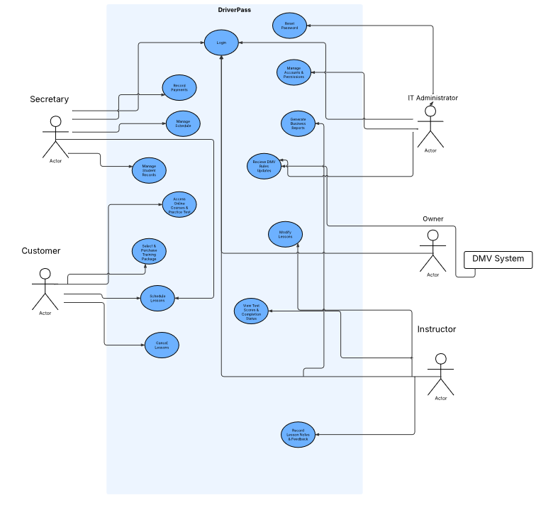

UML Activity Diagrams
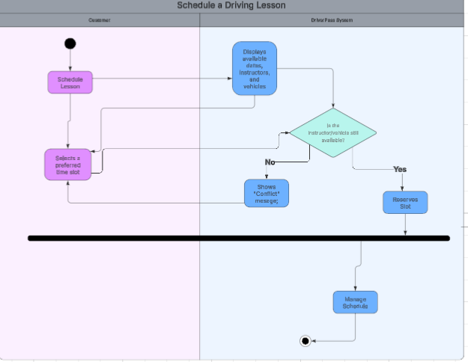
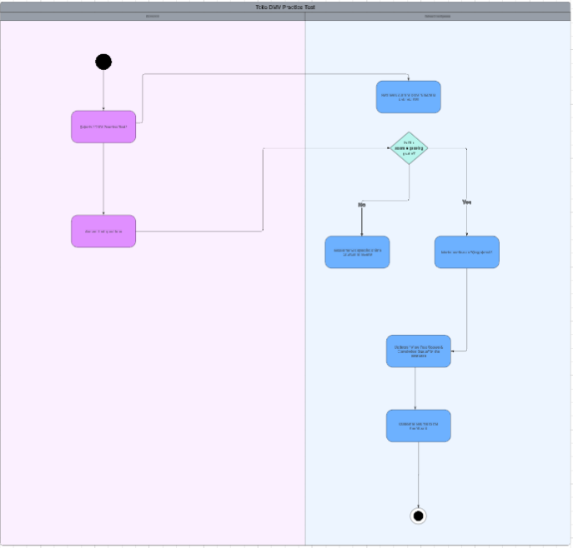

UML Sequence Diagram
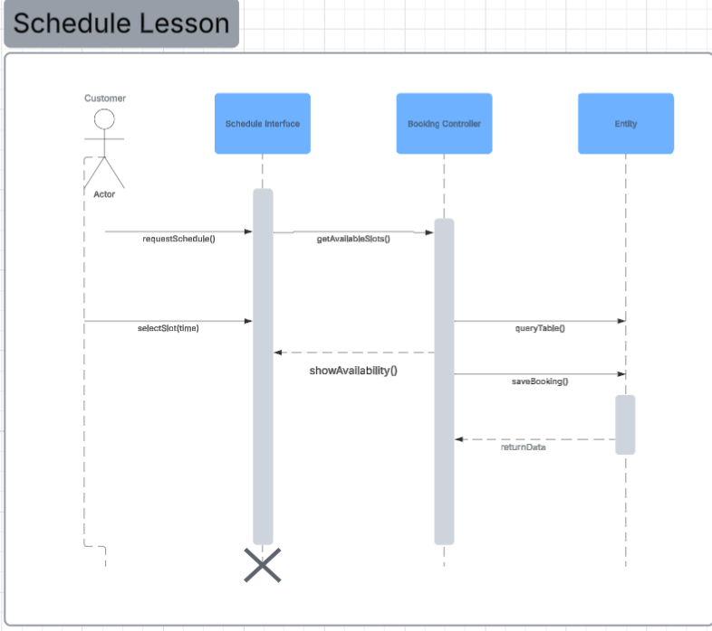

UML Class Diagram
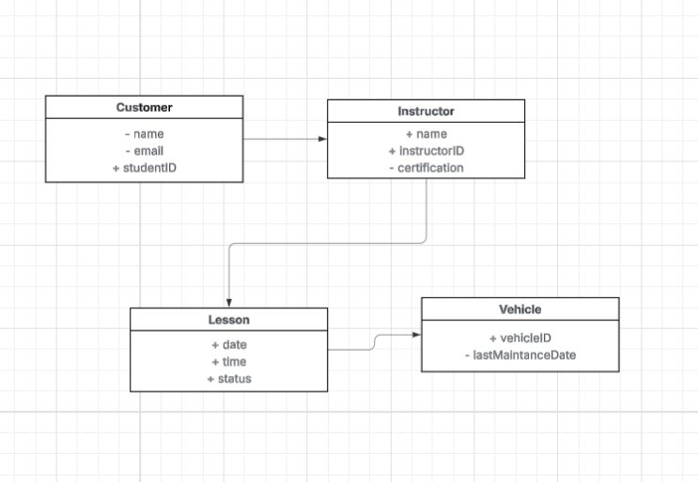

Technical Requirements
To support the DriverPass system design, the following technical infrastructure is required:
- Hardware:
  - Server-Side: Cloud-based hosting environment (e.g., AWS or Azure) to ensure 24/7 availability and scalability.
  - Client-Side: Standard desktop computers, tablets, or smartphones with modern processors capable of running web browsers.
- Software:
  - Frontend: HTML5, CSS3, and JavaScript framework (e.g., React or Angular) for a responsive web-based interface.
  - Backend: A server-side language such as Java or Python to handle business logic.
  - Database: A relational database management system (RDBMS) like MySQL or PostgreSQL to manage structured data for customers, lessons, and instructors.
- Tools & Infrastructure:
  - Security: SSL/TLS certificates for HTTPS encryption; role-based access control (RBAC) middleware.
  - APIs: Connection to DMV databases for real-time rule updates and a third-party API (like Stripe or PayPal) for secure payment processing.
  - Connectivity: High-speed internet access is mandatory for real-time data synchronization.
.

